NSW Department of Education 

Kelso Public School Behaviour Support and Management Plan

Overview
Kelso Public School is committed to explicitly teaching and modelling positive behaviour and to supporting all students to be engaged with their learning.
Our goal is to inspire every child to participate positively in the school community and beyond. We focus on promoting excellence, opportunity and success for every student, every day. We value and strive to develop safe, respectful learners in a caring, learning community.
Principles of positive behaviour support, trauma-informed practice, inclusive practice, and social-emotional learning underpin our daily practice. High expectations for student behaviour are established and maintained through effective role modelling, explicit teaching, and planned responses.
To achieve our mission, key programs prioritised and valued by the school community are:
- Positive Behaviour for Learning
- Berry Street Trauma-Informed Practice
- Trauma-Informed Practice for Improved Learning and Wellbeing
- Kelso Konnex
- School Chaplain
- PCYC Fit for Life

These programs prioritise social and emotional learning which supports good mental health, positive relationships and supports prevention of bullying.
Kelso Public School rejects all forms of bullying behaviours, including online (or cyber) bullying by maintaining a commitment to providing a safe, inclusive, and respectful learning community that promotes student wellbeing. Staff are committed to establishing evidence-based approaches and strategies that promote a positive climate where bullying is less likely to occur.
All members of the school community are active participants in building a welcoming school culture that values diversity and fosters positive relationships. A key component of a supportive school culture is building respectful relationships and an ethos that bullying is not accepted, in both online and offline environments. School staff actively respond to student bullying behaviour.

Partnership with parents and carers
Kelso Public School will partner with parents/carers in establishing expectations for engagement in developing and implementing student behaviour management and antibullying strategies, by:
- inviting parent/carer and student feedback through formal and informal means, such as Tell Them From Me surveys, school surveys, consulting with the P & C and local AECG
- using concerns raised through complaints procedures to review school systems, data and practices.
Kelso Public School will communicate these expectations to parents/carers through the school newsletter and school website. Our school proactively builds collaborative relationships with families and communities to create a shared understanding of how to support student learning, safety and wellbeing.

School-wide expectations and rules
Kelso Public School has the following school-wide expectations and rules:
To be respectful, responsible and resilient learners.
Respectful | Responsible | Proud | Safe | On Task
Be kind and value others | Be safe | Be your best | Work co-operatively | Ask for help
Use appropriate language | Be on time | Participate in all lessons | Walk indoors | Overcome challenges
Accept differences | Be ready to learn | Care for classroom and school equipment | No hat, play in the shade | Follow teacher’s instructions
Be an active listener | Play fairly | Be a team player | Use equipment safely | Be punctual

Behaviour code for students
NSW public schools are committed to providing safe, supportive and responsive learning environments for everyone. We teach and model the behaviours we value in our students.
The Behaviour Code for Students can be found at https://education.nsw.gov.au/policy-library/policyprocedures/pd-2006-0316/pd-2006-0316-01. This document has been translated into multiple languages and is available here: Behaviour Code for Students.

Whole school approach across the care continuum
Our school embeds student wellbeing and positive behaviour approaches and strategies in practices across the care continuum to promote positive behaviour and respond to behaviours of concern, including bullying and cyber-bullying behaviour.
These approaches and strategies are built on a foundation of evidence-based effective classroom practices that set the tone for engagement with learning and respectful relationships. These practices include:
- stating and explicitly teaching classroom expectations
- establishing predictable routines and procedures that are communicated clearly to students
- encouraging expected behaviour with positive feedback and reinforcement
- discouraging inappropriate behaviour
- providing active supervision of students
- maximising opportunities for active engagement with learning
- providing carefully sequenced engaging lessons that provide options for student choice
- differentiating learning content and tasks to meet the needs of all learners.
Care Continuum | Strategy or Program | Details | Audience
Prevention | Positive Living Skills | The Positive Living Skills (PLS) program is an evidence-based comprehensive mental health and wellbeing approach based on a combination of social and emotional learning, preventative mental health, resilience and life skills. | All
Prevention | Positive Behaviour for Learning | Positive Behaviour for Learning (PBL) consists of evidence-based strategies used daily by teachers to teach self-regulation, reduce impulsivity, increase focus and strengthen peer networks. | All
Prevention | Got it! Program | An early intervention, mental health initiative, supporting the social and emotional wellbeing of children and families. | K - 2
Prevention | Child protection | Teaching child protection education is a mandatory part of the syllabus. | Students K - 6
Prevention / Early Intervention / Targeted / Individual | Australian eSafety Commissioner Toolkit for Schools to prevent and respond to cyberbullying | The toolkit resources are categorised into four elements: Prepare, Engage, Educate and Respond. The resources are used to engage with the school community about creating and maintaining safe online environments to prevent cyberbullying incidents. The toolkit includes actions to report and manage cyberbullying incidents. | All
Early Intervention | Peaceful kids | Small group intervention to support and increase the coping strategies of students who are feeling anxious, stressed or who have poor resilience in a small group environment at school. | Individual students EI & K - 6
Targeted / Individual intervention | Learning and Support | The LST works with teachers, students and families to support students who require personalised learning and support. | All
Targeted / individual intervention | Attendance support | The LST refer students to the attendance co-ordinator who will convene a planning meeting with students, families and teachers to address barriers to improved attendance and set growth goals. | Individual students, attendance co-ordinator
Individual intervention | Individual behaviour support planning | This may include developing, implementing, monitoring and reviewing: behaviour support, behaviour response and risk management plans. | Individual students, parent/carer, LAST, AP

Planned responses to positive appropriate behaviour, inappropriate behaviour and behaviours of concern, including bullying and cyber-bullying

Identifying behaviours of concern, including bullying and cyberbullying
A behaviour of concern is challenging, complex or unsafe behaviour that requires more persistent and intensive interventions. A behaviour of concern does not include low-level inappropriate or developmentally appropriate behaviour. Bullying behaviour involves the intentional misuse of power in a relationship, is ongoing and repeated and involves behaviour that can cause harm. See Behaviour Charts.

Kelso Public School staff will identify inappropriate behaviour and behaviours of concern, including bullying and cyber-bullying through a range of channels, for example:

directly observing a student’s behaviours, interactions, verbal communications, or work produced (such as written materials, performances or artworks)

a person disclosing information that is not previously known, either because it is new information or because it has been kept a secret

concerns raised by a parent/carer, community member or agency.
Students or parents/carer can report bullying to any staff member. NSW public school principals have the authority to take disciplinary action to address student behaviours that occur outside of school hours or school grounds, including cyberbullying. Students who have been bullied will be offered appropriate support, for example through the school counselling service.
Responses to all behaviours of concern apply to student behaviour that occurs:
- at school
- on the way to and from school
- on school-endorsed activities that are off-site
- outside school hours and off school premises where there is a clear and close connection between the school and students’ conduct
- when using social media, mobile devices and/or other technology involving another student or staff member.

Preventing and responding to behaviours of concern
Planned responses to behaviours that do not meet school expectations are either teacher or executive managed. Staff use their professional judgement and refer to the All Settings/Playground Behaviour Charts in deciding whether a behaviour is teacher managed or executive managed. They should consider whether the behaviour poses a risk to the safety or wellbeing of the student or others.
- Teacher managed – low level inappropriate behaviour is managed by teachers in the classroom and the playground.
- Executive managed – behaviour of concern is managed by school executive.
- Corrective responses are recorded on Behaviour / wellbeing IT system. These include:
Classroom | Non-classroom setting
- rule reminder  - re-direct  - offer choice  - error correction  - prompts  - re-teach  - seat change  - stay in at break to discuss/ complete work  - conference  - detention, reflection and restorative practices  - communication with parent/carer. | - rule reminder  - re-direct  - offer choice  - error correction  - prompts  - re-teach  - play or playground re-direction  - walk with teacher  - detention, reflection and restorative practices  - communication with parent/carer.
Kelso Public School staff model, explicitly teach, recognise and reinforce positive student behaviour and behavioural expectations. Positive Behaviour for Learning and consist of evidence-based strategies used daily by teachers to teach self-regulation, reduce impulsivity, increase focus and strengthen peer networks.
We acknowledge that not all students are encouraged by the same thing or in the same ways. Younger students may be more motivated by adult attention while older students are typically more motivated by peer attention, activities, privileges, or freedom. When learning new skills, students need immediate and frequent reinforcement. As they develop mastery they respond to intermittent and long-term reinforcement to maintain their social behavioural efforts.
The use of verbal and non-verbal specific positive feedback is the most powerful way to:
- help adults and learners to focus on positive social behaviour
- increase the likelihood that students will use the expected behaviours and skills in the future
- decrease unexpected behaviour and reduce the need for corrective responses
- enhance self-esteem and build an internal focus of control.

Prevention  Responses to recognise and reinforce positive, inclusive and safe behaviour | Early Intervention  Responses to minor inappropriate behaviour are teacher managed. | Targeted/Individualised  Responses to behaviours of concern are executive managed
1. Behaviour expectations are taught and referred to regularly.  Teachers model behaviours and provide opportunities for practice.  Students are acknowledged for meeting school-wide expectations and rules. | 1. Refer to school-wide expectations and/or emotional regulation visuals and/or supports so that the student can self-regulate. | 1. Contact office to seek help from executive straight away if there is a risk. Otherwise notify student’s stage supervisor or executive ASAP and before the end of the school day.
2. Verbal and non-verbal specific positive feedback is paired with a positive, tangible reinforcer in a school-wide continuum for acknowledging expected behaviour. | 2. Use indirect responses including proximity, signals, non-verbal cues, ignore, attend, praise, redirect with specific corrective feedback. | 2. Executive/CT to take immediate steps to restore safety and return the situation to calm by using appropriate strategies such as: redirecting to another area or activity, providing reassurance or offering choices. Incident review and planning is scheduled for a later time, determined by the context and nature of the incident.
3. Tangible reinforcers include those that are:  - free and frequent  - moderate and intermittent  - significant and infrequent  Intermittent and infrequent reinforcers are recorded on Behaviour / wellbeing IT system. | 3. Use direct responses e.g. rule reminder, re-teach, provide choice, scripted interventions, student conference. Students have an opportunity to meet the classroom/playground behaviour expectation before low-level consequence is applied. | 3. Executive collects information and reviews the incident from multiple perspectives to determine next steps. Staff member who witnessed incident / Teacher / Executive to record incident on Behaviour / wellbeing IT system and contact parent/carer by email or phone. Executive/principal may consider further action e.g., formal caution or suspension.
4. Social emotional learning lessons are taught weekly. | 4. Teacher records Inappropriate Behaviour / wellbeing IT system by the end of the school day. Monitor and inform family if repeated. For some incidents, referral is made to the school’s anti-racism contact officer (ARCO) or anti-bullying co-ordinator. | 4. Refer to the school’s Learning and Support Team considering current and previous behaviour data. Other actions may include completing a risk assessment and/or collaboratively developing a behaviour support/response plan.
Teacher/parent/carer contact | Teacher/parent/carer contact | Teacher/parent/carer contact
Teacher contact through the parent portal or phone calls home are used to communicate student effort to meet expectations. Recognition awards for positive individual and class behaviour are given at fortnightly school assemblies. | Teacher contacts parent/carer by phone or email when a range of corrective responses have not been successful.  Individual planning and referral to Learning Support Team may be discussed. | Parent/carer contact is made by school executive to discuss any support and behaviour responses, including referral to the LST, school counsellor, outside agencies or Team Around a School.

Responses to serious behaviours of concern
Responses for serious behaviours of concern, including students who display bullying behaviour, are recorded on Behaviour / wellbeing IT system. These may include:
- review and document incident
- determine appropriate response/s, including supports for staff or other students impacted
- refer/monitor the student through the school learning and support team
- develop or review individual student support planning, including teaching positive replacement behaviour and making learning and environmental adjustments
- detention, reflection and restorative practices (listed below)
- liaise with Team Around a School for additional support or advice
- communication and collaboration with parents/carers (phone, email, parent portal, meeting)
- formal caution to suspend, suspension or expulsion.
The NSW Department of Education Student Behaviour policy and Suspension and Expulsion Procedures apply to all NSW public schools.

Reporting and recording behaviours of concern
Staff will comply with reporting and responding processes outlined in the:
- Incident Notification and Response policy
- Incident Notification and Response Procedures
- Student Behaviour Policy and Suspension and Expulsion procedures
Students and/or parents/carers can report cyberbullying to the eSafety Commissioner and reporting links for most sites, games and apps can be found at the eSafety Guide.

Time Out, reflection and restorative practices
Toilet and food breaks are always included when withdrawal from free choice play at either break is planned as a response to behaviour. The maximum length of time will be appropriate to the age/developmental level of the student.

Strategy | When and how long? | Who coordinates? | How are these recorded?
Reflection room – a structured debriefing and planning after a crisis event or behaviour of concern with an individual student (reflection) | Next day at either lunch or recess break | Assistant Principal | Documented in Behaviour / wellbeing IT system
Alternate play plan – withdrawal from free choice play and re-allocation to office or classroom for supervised play following breach in behaviour. The purpose is to assist the student to achieve the desired behaviour, to reflect on their behaviour and make positive choices – individual or group (Time Out) | Next break | Assistant Principal | Documented in Behaviour / wellbeing IT system
Restorative practice – peer mediation or circles in groups | Scheduled for either lunch or recess break | Assistant Principal | Documented in Behaviour / wellbeing IT system

Review dates
Last review date: Friday 31st January: Day 1, Term 1, 2025

Next review date: Tuesday 27th January: Day 1, Term 1, 2026

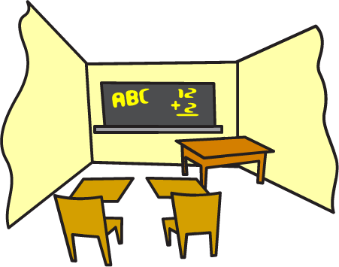

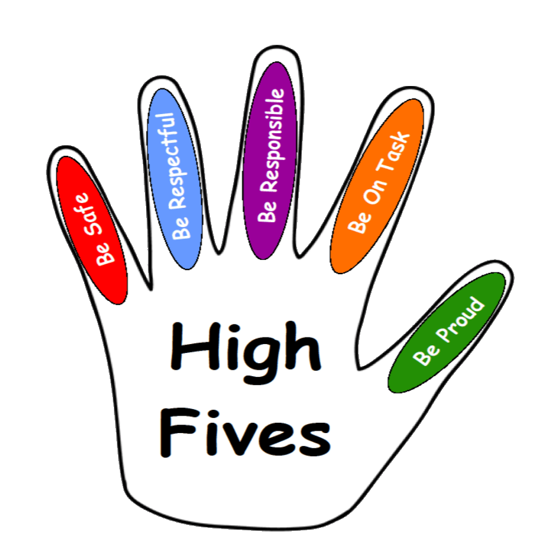
ALL-SETTINGS BEHAVIOUR CHART
Kelso Public School 2024
Record Behaviours |  |  |  |  | Major Behaviours
Inappropriate Language  - name calling  - ongoing direct swearing at student or teacher |  | Non-Compliance  - consistently ignoring a request /instruction from the teacher  - not completing work  - refusal to participate in lessons  - avoiding tasks. | Disruption  - distracting others  - shouting out  - making disruptive noises  - throwing objects (non-direct)  - back chatting/ arguing  - banging on walls, tables etc |  | Theft  - stealing school/ other persons property |  | Truancy  - leaving school grounds | Sexualised Behaviours  - inappropriate sexualised behaviours for the student’s age (determined by AP)
Defiance  - continual and absolute refusal to follow all teacher instructions. |  | Physical Contact (reaction)  - pushing/ shoving/pulling  - unwanted physical touching  - tripping | Property Misuse  - not handing in phones to office, use of electronic devices  - looking through others’ bags  - not respecting school property (musical equipment, technology, swinging on chairs etc). |  | Harassment  - intimidation of other students  - threatening staff/students  - stalking  - persistent laughing and teasing of others  - racist/ cultural comments |  | Physical Aggression (intent)  - kicking, hitting, biting, punching, pinching etc. with the intent to harm others  - inappropriate touching  - use of a weapon | Property Damage  - intentional breaking/ damaging of students, staff and/or school property  - vandalism  -smearing body fluids on school property
Inappropriate use of Technology  - cyber bullying  - searching for inappropriate images (Further action may be required after discussion with AP). |  | Truancy  - occasional truancy from class | Abusive Language/ Disrespect  - direct swearing at student/ teacher  - sexist comments  - calling out  - put downs  - rude gestures
3 records in a week = a major.
1 major = 2 sessions in timeout and reset room for 2 consecutive days.
Teacher Managed |  |  |  |  | Teacher managed with Executive Support
Step 1 | - Re direct student.  - Implement classroom behaviour management system or steps from the students IBSP. |  |  |  | Step 1 | - Access where the students is on the stress model of crisis. Determine the best response to the behaviour. If the student has an IBSP or RMP, refer to these documents for guidance.
Step 2 | - Discuss the behaviour immediately one to one, review school/ class expectations.  - Warn of consequences. |  |  |  | Step 2 | - Teacher records incident as a ‘major’ on Sentral and tags the relevant teacher/SLSO/AP/DP. The teacher selects ‘time out’ and ‘reset room’ for the next two consecutive days.
Step 3 | - Teacher follows through with a strategy or consequence. |  |  |  | Step 3 | - The AP reviews the Sentral entry, approves the ‘major’ coding and approves the teacher making parent contact.
Step 4 | - Time out in buddy class (10 minutes with work).  - Teacher/SLSO records the incident as a ‘record only’ on Sentral. Discuss with AP/DP.  - Contact parent if required. |  |  |  | Step 4 | - The teacher who responded to the incident will make the parent contact and log it in Sentral.  - The AP will send home a major letter in person or through registered mail and place a copy in the folder on KPS drive.

 | ⇨ | Step 1 | ⇨ | Step 2 | ⇨ | Step 3
 | ⇨ | - If immediate response is required, call office on 6331 1577 and ask for ‘executive response. They will first attempt to locate the appropriate stage AP, then other appropriate members of staff.  - Assess student safety (remove non-involved students if necessary). | ⇨ | - Principal / Deputy Principal / executive to make contact with parents / caregivers by letter, phone, interview or home visit.  - Teacher to complete Sentral entry.  - Possible warning / exclusion from excursions. | ⇨ | - Referral to time out room and reset room or  - Suspension (Principal’s discretion).
Repeated Record Behaviours
Data Decision Rule: If a student has three teacher managed incidents of behaviour over the course of a week or day this is then written as a record.
Three records of the same behaviour over a week, escalation to a Major incident is required. *Subject to discretion and discussion with stage supervisor/DP/Principal.

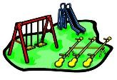
PLAYGROUND BEHAVIOUR CHART
Kelso Public School 2024
Record Behaviours |  |  |  |  | Major Behaviours
Disrupting/unsafe games  - taking others belongings  - running through others’ games  - playing unfairly  - tackling  - wrestling  - throwing balls at one another |  | Teasing  - excluding others  - name calling  - bad sportsmanship  - not sharing  - putting another student down | On-going defiance  - repeated refusal to follow reasonable instructions (3 or more times)  - verbal abuse to a teacher after instructions made  - absconding |  | Intimidation  - threatening to incite violence against a person or their family. |  | Physical aggression  - invading personal space and baiting a student/staff  - continual attempts to try to start violence.  - repeated intimidation | Vandalism  - defacing property  - damaging property  - graffiti  - smearing body fluids on school property  - not using bubblers/toilets appropriately.
Theft  - taking other students belongings without asking. |  | Out of bounds  - continuing to be playing/ eating in the wrong area. | Ongoing bullying  - threats, intimidation  - ongoing group intimidation of others  - continual exclusion |  | Assault with a weapon (sticks, stones etc)  - bringing knives, slingshots, textas etc.  - hitting, poking or throwing sticks that cause harm/injury |  | Sexual harassment  - inappropriate sexualised behaviours for the student’s age (determined by AP). Eg: sack whacking, pulling pants down, touching others sexually.  - using sexual comments as a means of threatening/ intimidating others | Fighting  - physical violence towards another student or staff (punching, kicking, grabbing, swinging)  - encouraging others to fight
Excessive abuse/ swearing at others  - inappropriate and derogatory language directed at a student or teacher.  - directed swearing |  | Minor physical contact  - small and sometimes accidental physical contact during a game | Property Misuse  - inappropriately using sports equipment.  - not using equipment safely  - throwing property  - not putting equipment away
3 records in a week = a major.
1 major = 2 sessions in timeout and reset room for 2 consecutive days.
Teacher Managed |  |  |  |  | Teacher managed with Executive support
Step 1 | - Re-direct student.  - Implement behaviour management strategy or steps from the students IBSP. |  |  |  | Step 1 | - Access where the students is on the stress model of crisis. Determine the best response to the behaviour. If the student has an IBSP or RMP, refer to these documents for guidance.
Step 2 | If behaviour continues …  - Walk with teacher  - Sit in designated place.  - Inform the classroom teacher of the student involved. |  |  |  | Step 2 | - Teacher records incident as a ‘major’ on Sentral and tags the relevant teacher/SLSO/AP/DP. The teacher selects ‘time out’ and ‘reset room’ for the next two consecutive days.
Step 3 | Repeated record behaviours (3 or more = major incident)…  - Enter the student onto Sentral and mark as further action required. |  |  |  | Step 3 | - The AP reviews the Sentral entry, approves the ‘major’ coding and approves the teacher making parent contact.
 |  |  |  |  | Step 4 | - The teacher who responded to the incident will make the parent contact and log it in Sentral.  - The AP will send home a major letter in person or through registered mail and place a copy in the folder on KPS drive

 | ⇨ | Step 1 | ⇨ | Step 2 | ⇨ | Step 3
 | ⇨ | - If immediate response is required, call office on 6331 1577 and ask for ‘executive response. They will first attempt to locate the appropriate stage AP, then other appropriate members of staff.  - Assess student safety (remove non-involved students if necessary).  . | ⇨ | - Principal / Deputy Principal / executive to make contact with parents / caregivers by letter, phone, interview or home visit.  - Teacher to complete Sentral entry.  - Possible warning / exclusion from excursions. | ⇨ | - Referral to time out room and reset room or  - Suspension (Principal’s discretion).

Repeated Record Behaviours
Data Decision Rule: If a student has three teacher managed incidents of behaviour over the course of a week or day this is then written as a record.
Three records of the same behaviour over a week, escalation to a Major incident is required. *Subject to discretion and discussion with stage supervisor/DP/Principal.
Bullying Response Flowchart

The following flowchart explains the actions Kelso Public School staff will take when they receive a report about student bullying, including bullying which may have occurred online or outside of the school setting. The timeframes will vary depending on the professional judgment of staff who receive the bullying complaint and their assessment of immediate risk to student/s.

